API Testing – User Profile

The Profile API allows an authenticated user to view and manage their personal profile details.
- Route: GET /api/users/profile
- Access: Private / Authenticated
- Purpose: Retrieves the profile information of the currently logged-in user.
Request Header:
Authorization: Bearer <JWT_TOKEN>
Explanation:
- JWT Token: Verifies the user's identity.
- User Details: Returns information such as name and email.
- Authentication: Only logged-in users can access the profile.
- Database: Profile details are retrieved from MongoDB through Mongoose.
After sending the request, the server validates the JWT token, identifies the user, retrieves the profile data, and returns the details as a JSON response.
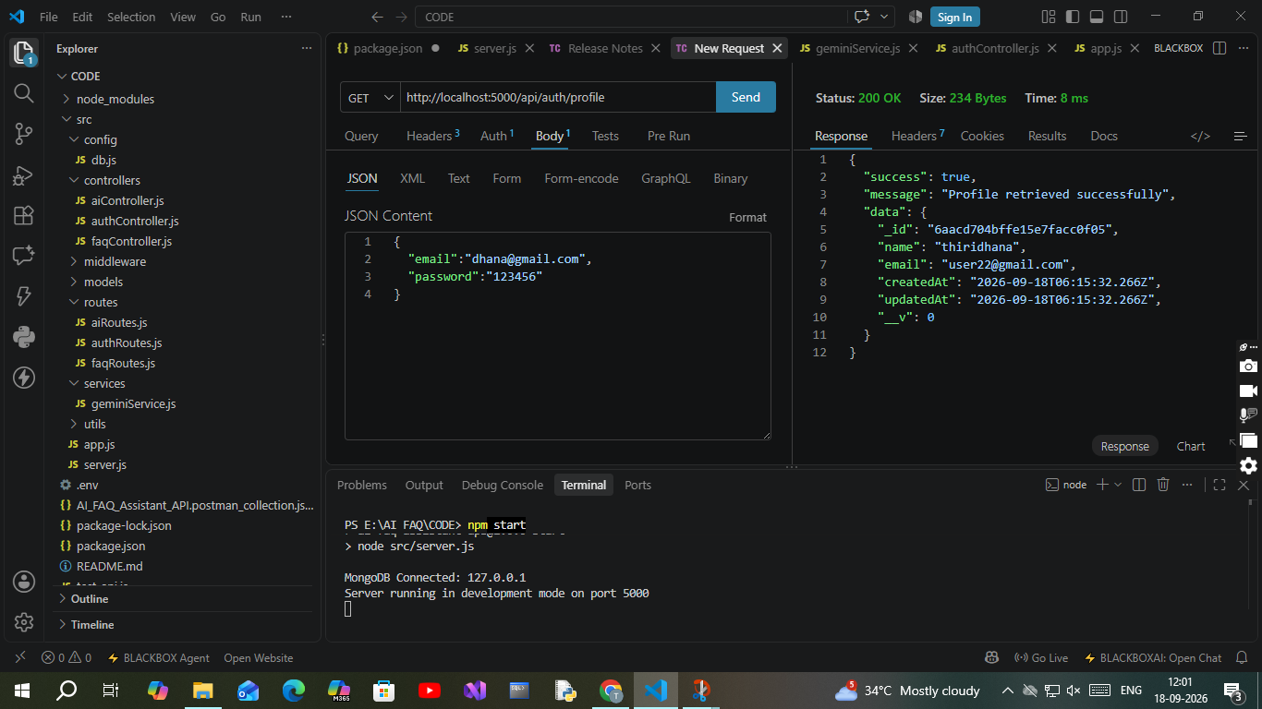

OUTPUT SCREENSHOT:

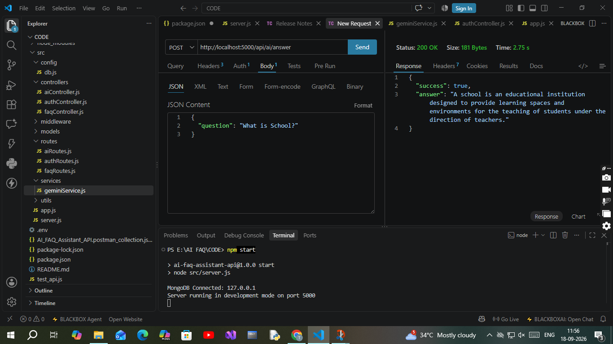
The AI Assistant successfully processes the user’s question and returns an AI-generated answer.
Request:
{
"question": "What is School?"
}
Output:
{
"success": true,
"answer": "A school is an educational institution designed to provide learning spaces and environments for the teaching of students under the direction of teachers."
}
Result:

- Status: 200 OK
- Success: true
- Answer: AI-generated response to the user’s question.
- The response is returned in JSON format.

